**(Question 1 from email)**

Is this panel considered the SCOM event log panel?

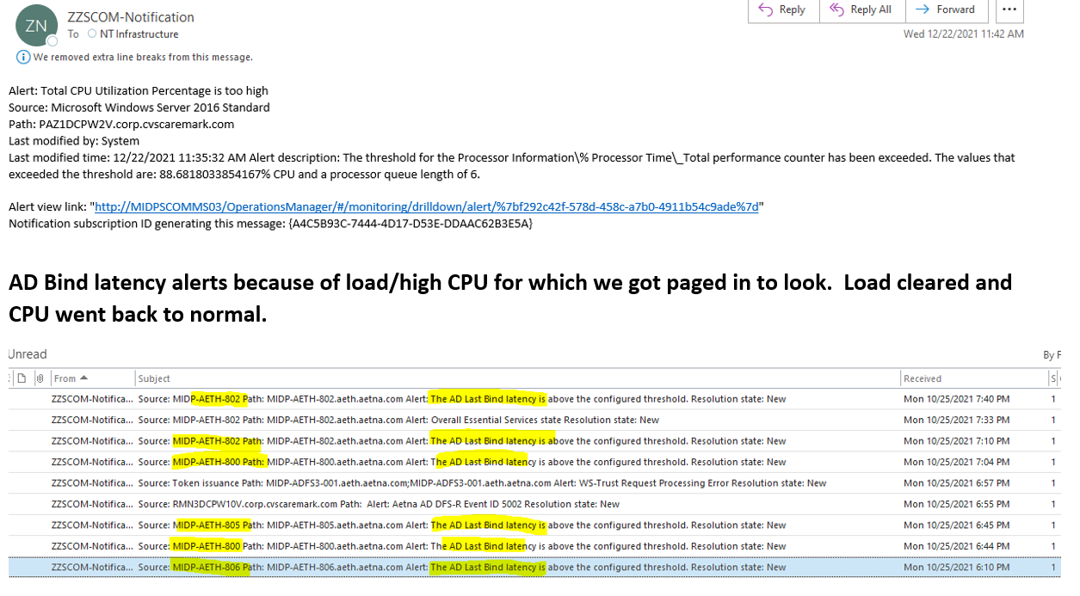

**(Question 3 from email)**

Are both of these email alerts considered SCOM events? If not, can you differentiate which of these sources is indeed the SCOM alert?

Email from CVS heath alert MIR3 sent to Jim Rose (See below)

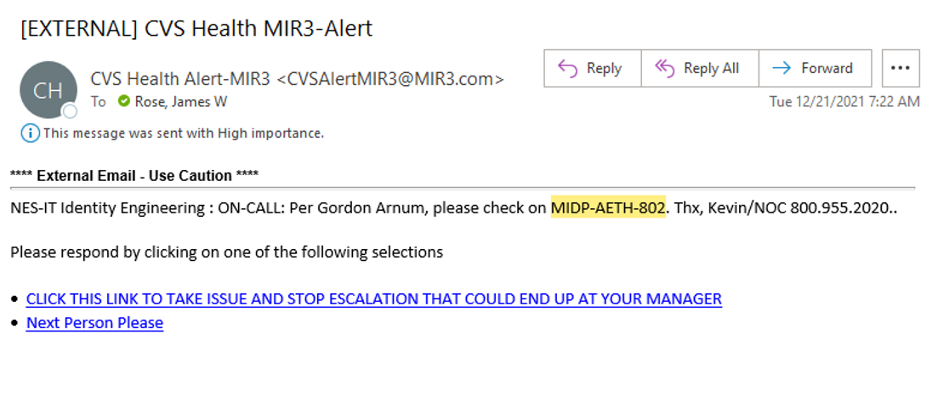

Email from ZZSCOM-notification sent to NT Infrastructure (See below)

